PACE INDIAN STUDENT ASSOCIATION

Where every Pace festival feels like home.

The Pace Indian Student Association (PISA) is a Lubin School of Business graduate student-led community at Pace University dedicated to bringing Indian students together, celebrating Indian culture, and creating a sense of home away from home.

Through cultural celebrations, social experiences, networking, guidance, collaborations, and community initiatives, PISA helps students connect, belong, and create lasting memories together.

Established in 2008, PISA has become an integral part of the Pace University community.

MORE THAN A CLUB, A COMMUNITY.

Culture

Celebrating India's diverse festivals, traditions, music, dance, food, fashion, and heritage while sharing Indian culture with the wider Pace community.

Community

Creating spaces for students to meet, make friends, celebrate together, and build meaningful connections at Pace.

Support & Guidance

Connecting students with peers, alumni, and community members who can provide experiences, resources, guidance, and support as they navigate university and life in New York.

Networking

Creating opportunities to connect with alumni, professionals, community leaders, and organizations — building relationships that extend beyond Pace.

Belonging

At the heart of PISA is one simple idea: everyone deserves to feel at home. PISA brings students together across backgrounds and experiences to find their people, celebrate who they are, and create memories that last beyond university.

EXPERIENCE PISA

PISA brings the community together throughout each semester through signature celebrations, cultural experiences, social events, networking, and collaborations.

The PISA Premiere

The opening celebration of every semester — a Bollywood-inspired welcome featuring music, dance, food, introductions, and the unveiling of PISA's semester team, vision, and activities.
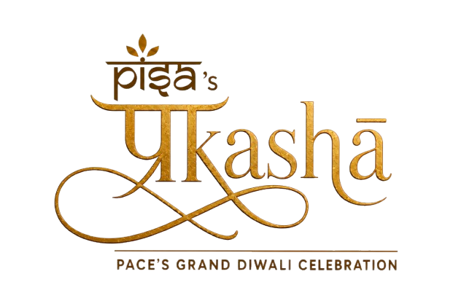
Prakāshā

Pace's Grand Diwali Celebration. PISA's signature fall celebration bringing the lights, traditions, music, dance, food, and energy of Diwali to the Pace community.

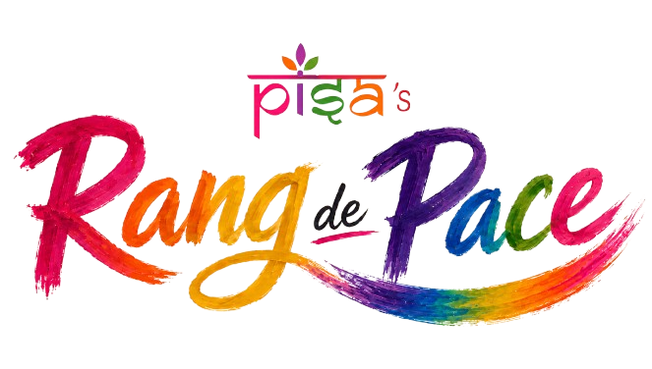
Rang De Pace

Pace's Holi Celebration. PISA's signature spring celebration bringing the colors, music, dance, food, and spirit of Holi to campus.

Cultural & Social Experiences

Beyond signature festivals, PISA creates immersive opportunities to experience Indian culture through workshops, showcases, outings, and social experiences.

Our Navratri workshops introduce Garba and Dandiya to the wider Pace community, while our annual International Yoga Day experience brings students, faculty, staff, and professors together through yoga and Indian wellness traditions.

In Spring 2026, PISA presented a large-scale Indian Mock Wedding experience, showcasing the traditions, rituals, fashion, music, food, and celebrations of an Indian wedding.

Other experiences have included cultural visits to destinations such as BAPS Swaminarayan Akshardham and community activities designed to bring students together beyond the classroom.

Alumni & Professional Networking

Connecting students with alumni, professionals, and community leaders through conversations, networking, and mentorship opportunities.

Collaborations

PISA believes in Vasudhaiva Kutumbakam — “the world is one family.”

We collaborate with student cultural organizations, clubs, academic groups, and community organizations to promote unity and cross-cultural understanding. Through these partnerships, we share Indian fashion, music, dance, traditions, and Sanskriti, while celebrating the cultures of others.

CONNECTED BEYOND PACE

Rooted at Pace. Connected to New York.

PISA's community extends beyond the university campus.

We have developed meaningful relationships with the Consulate General of India in New York, representatives of the New York State Assembly, Pace University leadership, faculty, alumni, and the wider Indian-American community.

These connections create opportunities for students to participate in cultural and civic experiences beyond Pace while bringing university leaders, public officials, and community representatives into PISA's celebrations.

PISA is part of a community much bigger than our campus.

THE PEOPLE BEHIND PISA

Student-led. Community-driven.

PISA is led by approximately 15–25 students each semester, bringing together graduate student leaders and associates across Events, Marketing, Outreach, Culture, Media, and Operations.

The Executive Board — President, Vice President, Secretary, and Treasurer — works alongside Directors and associates to plan experiences, build partnerships, support students, and bring PISA's vision to life.

Built by students. Experienced by everyone.

FIND YOUR HOME AT PACE.

Whether you're new to Pace, looking to meet people, hoping to stay connected to Indian culture, seeking guidance, or simply looking for a community — PISA welcomes you.

Celebrate. Connect. Belong.

Pace Indian Student Association

Where every Pace festival feels like home.

---

STAY CONNECTED

Instagram
@pace_pisa

PISA Student Portal
[AI-powered PISA Portal Link]

Your gateway to PISA events, resources, opportunities, updates, and community information.

Settersync
https://settersyncnyc.pace.edu/organization/pisa

Stay connected with PISA and the wider Pace student community.

